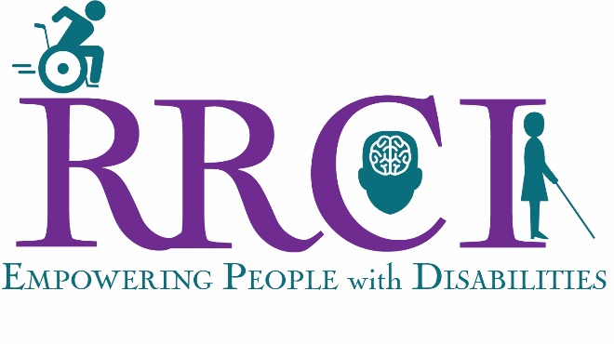

Board Member Agreement

I, , understand that as a member of the Board of Directors of Red Rock Center for Independence, I have a legal and ethical responsibility to ensure that the organization does the best work possible in pursuit of its goals. I believe in the purpose and the mission of the organization, and I will act responsibly and prudently as its steward. As part of my responsibilities as a board member:
- I will interpret the organization's work and values to the community, represent the organization, and act as a spokesperson.

- In turn, I will interpret our constituencies' needs and values to the organization, speak out for their interests, and on their behalf, hold the organization accountable.

- I will attend at least 75 percent of board meetings, committee meetings, and special events.

- I will attend our annual board training/planning retreat.

- I will participate in fund raising activities in support of RRCI.

- I understand that I am encouraged to make personal contribution, either financial or volunteer time in addition to attendance at Board and Committee meetings.

- I will excuse myself from discussions and votes where I have a conflict of interest.

- I will promote and protect confidentiality and handle sensitive situations with care.

- I will stay informed about what's going on in the organization. I will ask questions and request information. I will participate in and take responsibility for making decisions on issues, policies, and other matters. I will not stay silent if I have questions or concerns.

- I will work in good faith with the Executive Director and other board members as partners toward achievement of our goals.

- If I don’t fulfill these commitments to the organization, I will expect the board president to call me and discuss my responsibilities with me.

The organization is responsible to the board members for . . .

- I will be sent, without having to request them, monthly financial reports and an update of organizational activities that allow me to meet the "prudent person" standards of the law. (The "prudent person rule," applied in many legal settings in slightly differing language, states that an individual must act with the same judgment and care as, in like circumstances, a prudent person would act.)

- Director and Officers Insurance Policy that will cover up to one million dollars per incidence.

- Opportunities will be offered to me to discuss with the executive director and the board president the organization's programs, goals, activities, and status; additionally, I can request such opportunities.

- The organization will help me perform my duties by keeping me informed about issues in the industry and field in which we are working and by offering me opportunities for professional development as a board member.

- Board members and the Executive Director will respond in a straightforward fashion to questions that I feel are necessary to carry out my fiscal, legal, and moral responsibilities to this organization. Board members and staff will work in good faith with me toward achievement of our goals.

- If the organization does not fulfill its commitments to me, I can call on the board president and executive director to discuss the organization's responsibilities to me.
Signed: by , Board Member Date

and by , President, Board of Directors Date

